Software Requirements Specification
for
T.A. Solutions
Version 1.0
Prepared by Brian Blondet
Kean University
February 25, 2020
Table of Contents
Table of Contents ii
Revision History ii
1. Introduction 1
1.1 Purpose 1
1.3 Intended Audience and Reading Suggestions 1
1.4 Product Scope 1
1.5 References 1
2. Overall Description 1
2.1 Product Perspective 1
2.2 Product Functions 2
2.3 User Classes and Characteristics 3
2.4 Operating Environment 4
2.5 Design and Implementation Constraints 4
2.6 User Documentation 4
2.7 Assumptions and Dependencies 4
3. External Interface Requirements 5
3.1 Mobile User Interfaces 5
3.2 Web User Interfaces 6
4. User Functional Requirements 6
4.1 Common 6
4.2 Administrators 6
4.1 Supervisors 7
4.1 Tutors 7
4.1 Students 7
5. Non-Functional Requirements 7
4.1 Hardware Requirements 8
4.2 Software Requirements 8
4.1 Security Requirements 8
4.1 Availability Requirements 8

Revision History
Name | Date | Reason For Changes | Version
Brian Blondet | 2/25 | Baseline | 1.0

Introduction

Purpose
The purpose of this document is to provide a detailed specification of the software system, T.A. Solutions. The product to be a web and android mobile application that will streamline the check-in/out process for tutors and students as well as log all their activity to provide administration with analytics of the tutoring and subject

Intended Audience and Reading Suggestions
This document contains a high-level description of T.A. Solutions product and is intended as a guideline for the development team.

Product Scope
T.A. Solutions seeks provide administrators of tutoring programs a means to easily monitor their program by digitally logging sessions, automated flagging, and data analytics, while also streamlining the sign-in process for both Student and Tutor through mobile and web-based systems. As a result, T.A. Solutions will aid administrative decision making by informing users of issues within the program and predicting program growth.

By the end of the timeline there should be a successful development of the following:
- Mobile App
- Web application
- Analytics and reports
- Data processing/Analytic Tools
There should be successfully tested the system by either deploying it to code samurai or a
small tutoring group.

References
Guide to creating Software Requirement Specification by Karl E. Wiegers.

Overall Description

Product Perspective
T.A. Solutions aims to be integrated to an existing tutoring program(s) at any university by taking over the check in/out process for both students and tutors. By taking over these processes those overseeing the tutoring program will be able to view the digital logs and data analytics provided by our product. This product is intended to be used on Android and web application, however administrative functions for the admin and supervisors will be only available on web. If a supervisor were to login to mobile, they would be brought to the tutor by default.

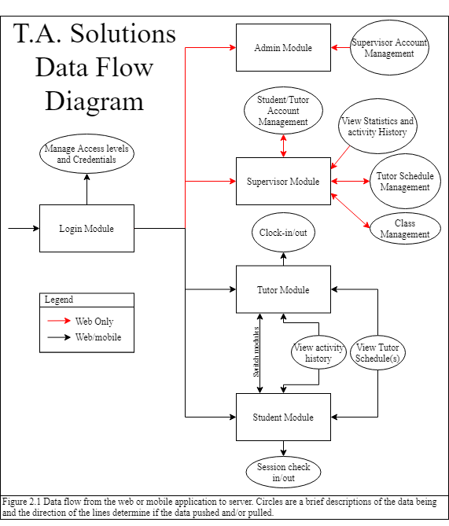
Product Functions

- One admin with a module on web and direct access to the database systems.
- User logging in with valid credentials will be brought to appropriate modules.
- Admin and Supervisor modules will have all their functionality on the web application.
- If an admin or supervisor were to login on mobile, the tutor module will be their default view.

- Admin Module:
  - Supervisor Account Management: Allows admin to promote/demote supervisor privilege to existing users.
- Supervisor Module:
  - Student/Tutor Account Management: Allows supervisor to promote/demote users between student and tutor using their email. Tutor permissions should only last one semester.
  - View Statistics and Activity History:
    - View and edit check in/out of students.
    - View and edit clock in/out of tutors.
    - Edits should be logged to database.
    - View will have graphics with parameters that can be edited.
    - Tutor Analytics based off activity history.
  - Tutor Schedule Management: Sets tutor user schedules and the classes they are proficient in.
  - Class Management:
    - Create or delete classes that will be listed under tutors. Must include Class name, ID, and description.
    - An option to require tutoring to take place at specific GPS location.
- Tutor Module:
  - Clock in/out: Digitally log tutor clock in/out to the MySQL Database.
  - Tutor Clock in will create a QR code and alphanumeric code for students to check in/out.
  - View Tutor Schedule(s): view personal schedule or schedule of all tutors.
  - View Activity History: view clock in/out history or tutoring history.
- Student Module:
  - Session Check in/out: Student must use a code or QR code provided by the tutor. If GPS checking is enabled the program will compare GPS coordinates and store a Boolean. No GPS coordinates will be stored.
  - View Activity History: view tutoring session history.
  - View Tutor Schedule: view schedule of all tutors.

User Classes and Characteristics
Admin is anticipated to be a member of the IT department of a university or school system adopting T.A. Solutions. They will need experience in MySQL and with webservers for installing the T.A. Solutions web application. The other users do not require strong technical backgrounds

Supervisors are expected to be from different departments of a university and running the tutoring program for said department. I.E. Computer science, Mathematics, Biology. User is expected to be a power user because they will be responsible for scheduling tutors and checking their hours.

Tutors will be regularly using T.A. Solutions software for digitally logging their work hours and providing a means to check into sessions for students looking for their services.

Student users will vary in use depending on if they are seeking tutoring for their classes. Furthermore, they must use a tutor’s QR code or alphanumeric code to check in to their session.

T.A. solutions user hierarchy will allow the topmost users to promote users below to other access levels below their own (Figure 2.2). New users will be Students by default, until they are granted other permissions. Admin permissions must be granted by developers.
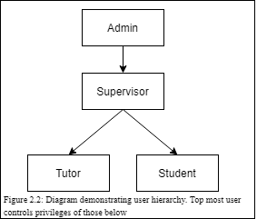

Operating Environment
T.A. Solutions is an open source web and android mobile application that requires a webserver and MySQL server. The web application can run on Google Chrome, Microsoft Edge, and Firefox.

Design and Implementation Constraints
Due to limited time for development, we will be prioritizing core functionality of the product. See more detail in section 4 Functional Requirements.

Currently there are no plans for development in Apple’s mobile IOS.

User Documentation
FAQ page and help page will be available on the web application.

External Interface Requirements

Mobile User Interfaces
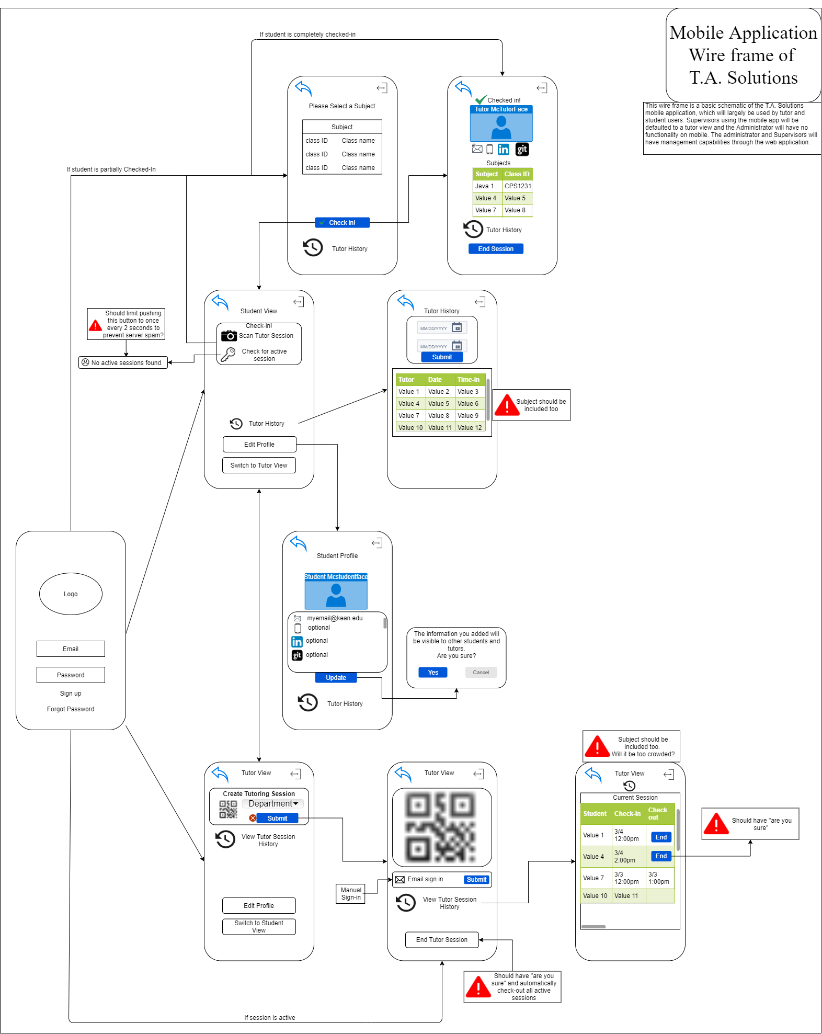

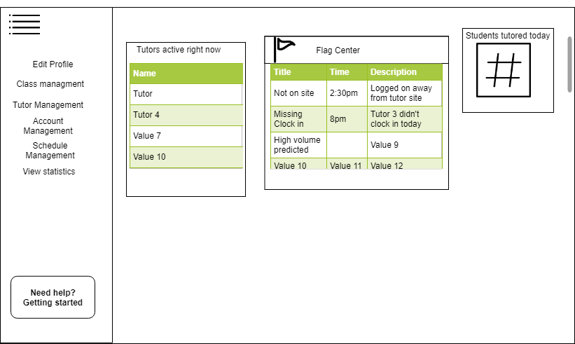
Web User Interfaces

Functional requirements
Highlighting Conventions in this document represent their priority. Green represents high development priority and yellow represents low development priority

Common
Req0001: Users that want to access the application from a mobile device will be required to download and install the application from the Google Play Store.
Req0002: All new users created are defaulted to a student account type.
Req0003All users can login to the application with the supplied user ID and password.
Req0004: Successful login to the application will display dashboard appropriate to the user account type that logged in.

Administrators
Req0100: Administrator access is limited to the web application and will not be able to log onto mobile.
Req0101: Administrators can create, modify or delete any user account or account information.
Req0102: Administrators can create, modify or delete supervisor accounts.

Supervisors
Req0201: Supervisors can create and delete classes must require class name, class ID, and brief description.
Req0202: Supervisors can promote and demote one to many student accounts to tutors.
Req0203: Supervisors can set specific account expirations dates when promoting tutor accounts.
Req0204: Supervisors can view tutor ratings and can view tutor notes of students.
Req0207: Supervisors can generate account activity reports (user logins, workday logins, check-in\out, tutor and student analytic reports).

Tutors
Req0301: Tutors can choose from list of departments with when clocking in.
Req0302: Tutors can clock-in\out of their tutoring workday.
Req0303: Tutor session QR codes are generated during clock-in to use for check-in purposes for tutoring sessions.
Req0304: Tutors can check-in a student into a tutoring session using a QR code.
Req0305: Tutors can check-in a student into a tutoring session with user email.
Req0306: Tutors can check-out a student manually.
Req0307: Tutors can view and change their account information.
Req0308: Tutors can view their tutoring history and organize view by specific courses.
Req0309: Tutors can share session history page to email app
Req0310: Tutors can make notes about specific students which are viewable to supervisors.

Students
Req0400: Students can login into the application with their user ID and password
Req0401: Successful login of the student should default their view to the student dashboard.
Req0402: Students must choose the departments they want to use/see.
Req0403: Students can check-in to tutoring session by scanning the tutor’s QR code.
Req0404: Students can “check for existing session” to activate session once a tutor has clocked them in
Req0405: Students can view and change their account information.
Req0406: Students can view their tutoring history and specify the subject or view all.
Req0407: Students can view a tutors profile, which contains contact the tutor has input such as email.
Req0408: Students are given the option to rate their tutor’s performance and leave review after checking out of a tutor session.
Req0409: new users are student users by default

Non-Functional Requirements

Hardware Requirements
Req0500: Accessing the application on a mobile platform will require an Android OS device.
Req0500: The system requires the mobile application and web application is utilized from a device connected to the Internet.
Req0501: The system requires a web server to process the web application.
Req0502: The system requires a database server to allow users and applications to centrally access the data.
Req0503: The system should be operational on different screen sizes and internet connection speed.
Req0504: The system should make use of the camera on the android device. The camera should be used for QR code scanning.

Software Requirements
Req0600: The Android application must support Android devices running on OS versions 4.0.3 or higher.
Req0601: The Android application will run quarterly maintenance cycles to provide updates for the end users.
Req0602: The web application should support all commonly used web browsers (Google Chrome, Mozilla FireFox, Microsoft Internet Explorer)

Security Requirements
Req0700: Students can only view his/her own account and activity information and not that of any other student, tutor or administrator.
Req0701: Tutors can only view his/her own account and activity information and not that of other tutors or administrators.
Req0702: Administrators can only view his/her own account and not that of other administrators.
Req0703: The system must store passwords in bcrypt hashes and not reveal passwords to any users.

Availability Requirements
Req0800: The system should always be available. Maintenance should be scheduled and communicated in advance and limit downtime to 3 hours.

